**BRIEFING ON AET UPDATE**

On-boarding meeting for programs programmes coordinator was held on the 17th of January on a year contract that ends in December ,2025. The meeting location was online which began at 6:30pm and ended at 9pm.In attendance were Michael Asare Bediako, Louis Hesse-Odamtten, Ewoenam Amenu Yakor and Rachel Annoh.

In the meeting KPIs were discussed and it was tasked that introductory email is sent to all General managers. I then visited Upplause consulting office to acquaint with Africa Firm team. There was also presentation on new programs lined - up of AET.

A post was to be made on 19th January 2024 on our social media introducing Rachel Annoh as new Programs Manager as well as to congratulate all the graduating fellows. Also, a meeting was scheduled on the Monday,22nd January 2024 to introduce AET scholars to New Programs Assistant.

All AET possessions to new programmes coordinator was to be handed over for perusal but I only received soft copy documents of past reports on AET with no physical possession till date. All efforts have been unsuccessful. Hoping to at least get a device for only AET purpose, AET contact lines so that calls are treated official as well as a router for internet assess.

**WEBSITE**

‘Telephone contacts on the website are not functional and website is not attractive’ has been feedback/responds to why some doners refused to sponsor or visit the site. More so, I am not identified on the website as a team member for which I have to continue to defend verbally, hence lowers trust from fundraising sources I reached out to, hence fundraising has not been effective. Pledgers do not respond to my calls anymore because they do not see how authentic I am to follow up on them and this has made my work quite ineffective.





**LIVE A GOOD LIFE CAMPAIGN (SCHOOL OUTREACH)**

This session was designated to all scholars during our first online meeting to reach out to their catchment schools and community folks to encourage them to stay focused and lead a good life. Topics such as teenage pregnancy, drug abuse, hygiene and improving academic lifestyle were focused on. To climax it is a joint visitation to five senior high schools on 22nd November, 2024.The climax outreach is dubbed ‘YES I CAN’, where we will move as a team to as well create AET visibility.

T-shirts and handkerchiefs have been designed for the outreach. Below are the designs for approvals.



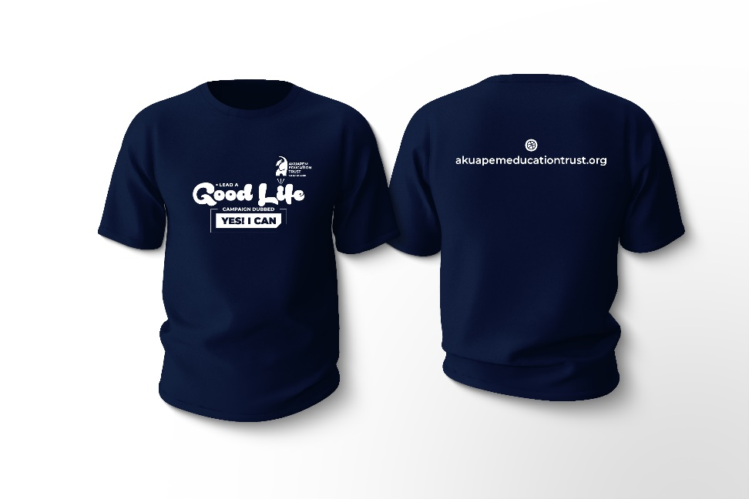

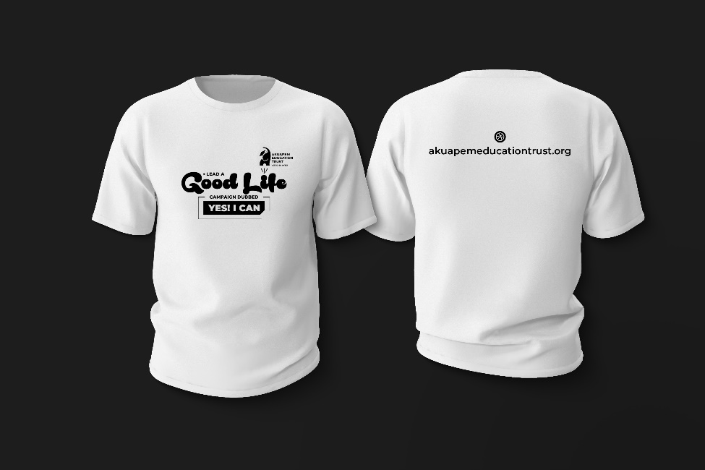

The scholars preference for T-shirt was treated special and hence the data is as presented below;

**T-Shirt Preferences**

|  |  |  |  |
| --- | --- | --- | --- |
| **Name** | **Size** | **Preferred Colour** | **Preferred Name** |
| 1. Gyampo Adelaide Oppong | M | Blue-Black | Adel |
| 1. Obuobi Solomon | XL | White | PAA SOLO |
| 1. ⁠Adu Afari Derrick | XL | Blue-Black | AFARI |
| 1. Opare Priscilla | M | Black | Prilla |
| 1. Ofori Daniel | XL | Blue Black | Daniola |
| 1. ⁠Adu Beatrice | Large | Blue Black | Beatrix |
| 1. Boateng Eric | Large | Black | Eric |
| 1. Takyi Deborah Safowaa | M | Sky Blue | Queen Derby |
| 1. Priscilla Nyarkoa Antwi | M | White | Nyarkoa |
| 1. ⁠Josephine Nyantekyiwa Sarpong | S/M | White | Nyantekyiwa |
| 1. Adutwumwaa | M | White | Adutwumwaa |
| 1. Caroline Kwayisi | M | White | Carol |
| 1. ⁠Addo Emmanuel Attuah | XL | White | Manuel |
| 1. David Harrison Addo | XL | Blue-Black | Harrison |
| 1. Ernest Ohene | Large | Lemon-Green | Allkingson |

**BUDGET FOR LEAD A GOOD LIFE CAMPAIGN**

|  |  |  |
| --- | --- | --- |
| ITEM | QUANTITY/GHC | AMOUNT/ GHC |
| TRANSPORTATION | 15 SCHOLARS | 750 |
| DONATION | 5 SCHOOLS | 5000 |
|  | TOTAL | 5750 |

**ODWIRA INTERNATIONAL QUIZ**

The quiz plan was on course

|  |  |  |
| --- | --- | --- |
| ITEM | ESTIMATED SERVICE CHARGE(GHC) | CURRENT CHARGE(GHC) |
| Venue | 1000 | 2000 |
| Quiz moderators | 200 | 1000 |
| Quiz Bells | 200 PER ONE | 800 PER ONE. (3600) |
| Time and Score keepers | 150 | 1500 |
|  | TOTAL | 8900 |

**SCHOLARS FEES AND FEEDBACK**

Check in on scholars has been of high percentage with all scholars’ fees paid. Fourteen of the scholars have completed their tertiary education and one is in the final year last semester. Hence the celebrating covers them all. However, there are areas reimbursement for Deborah, Daniel and Priscilla of which would be discussed at our scheduled meeting. Each scholar was tasked to write his /her story to update website. Attached are the received stories and articles. Here are some pictures of t shirt sponsorship.

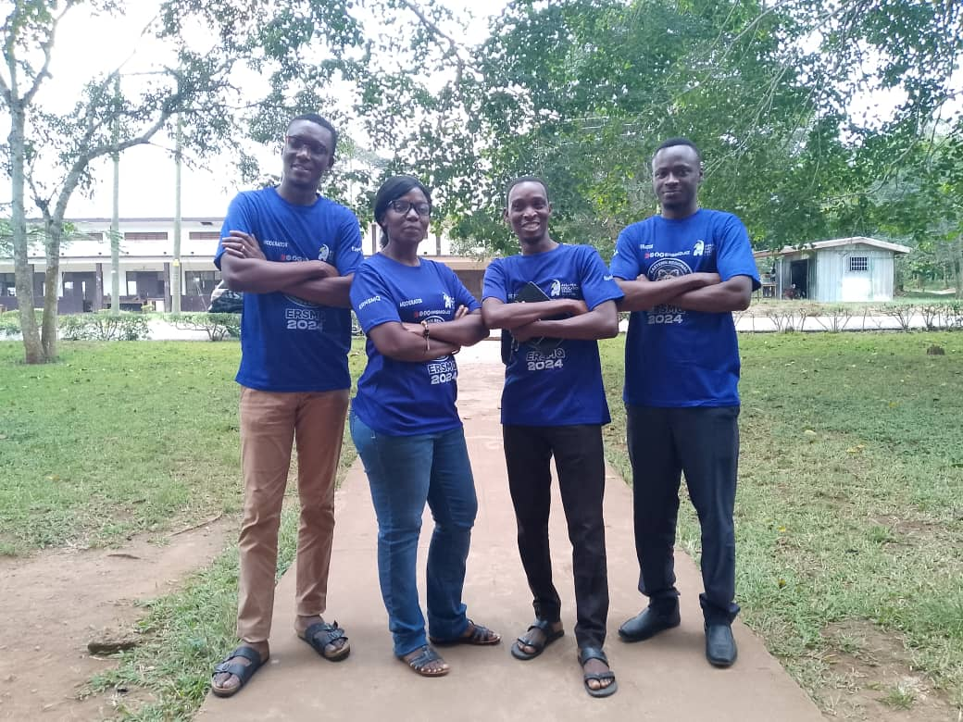

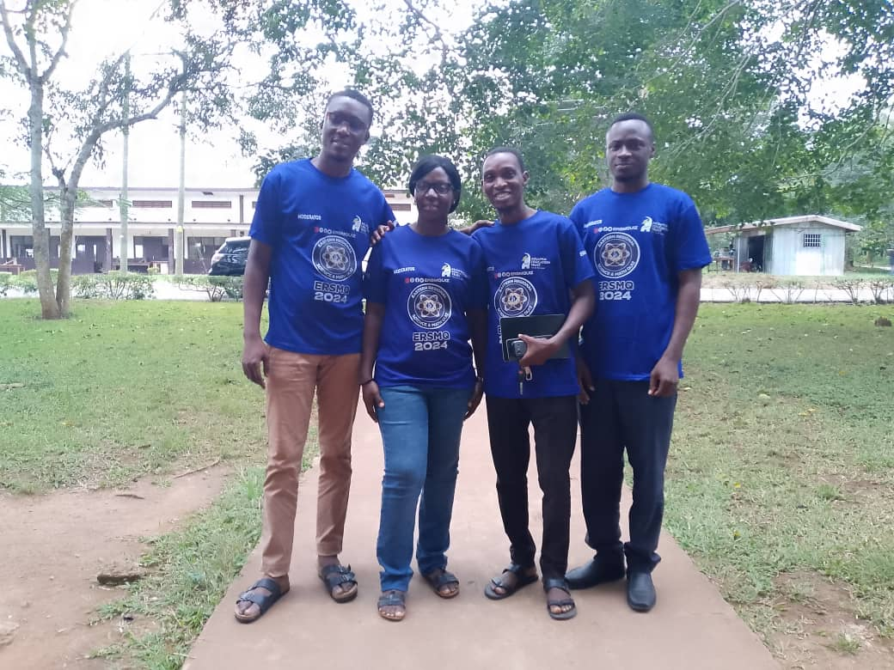

Below are a section of the students briefed during the Eastern Championship.

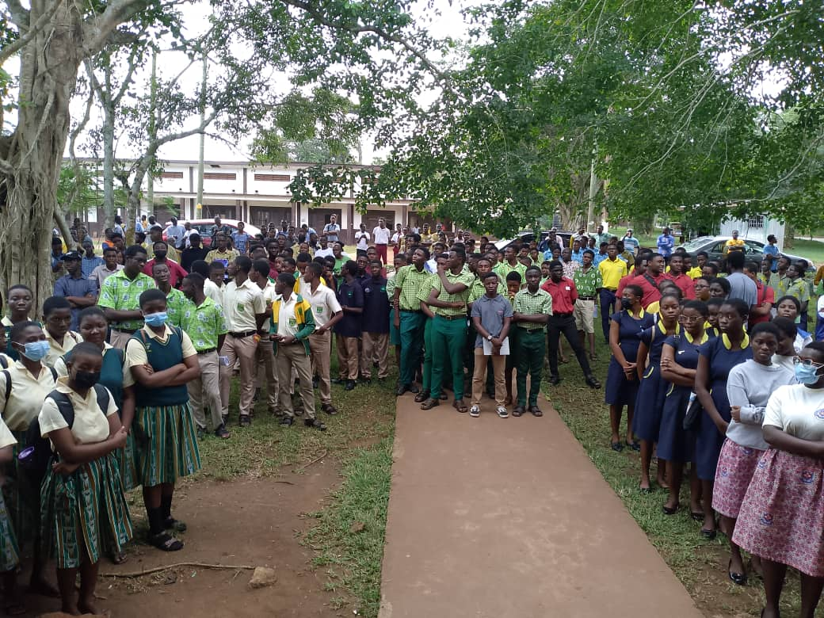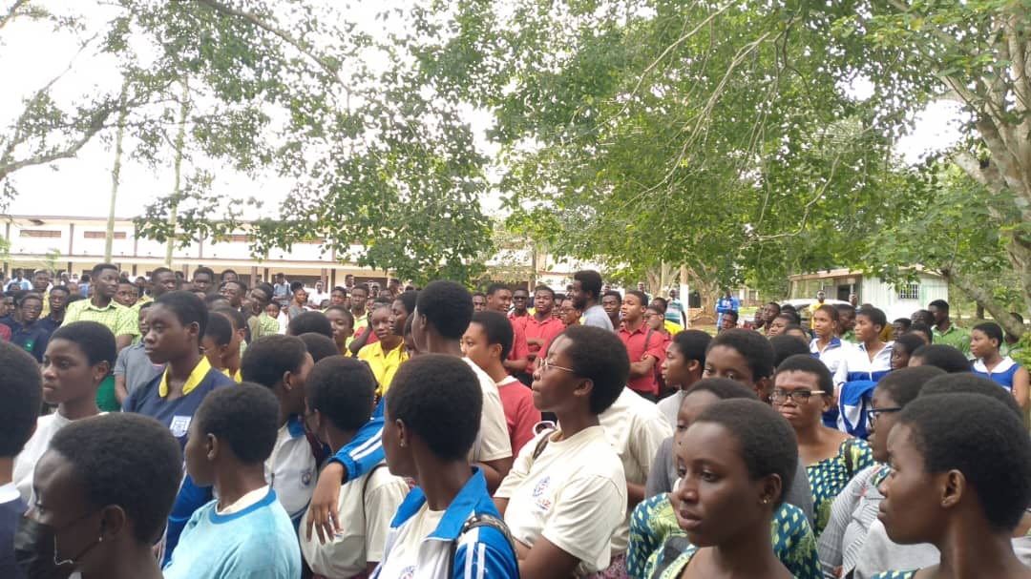

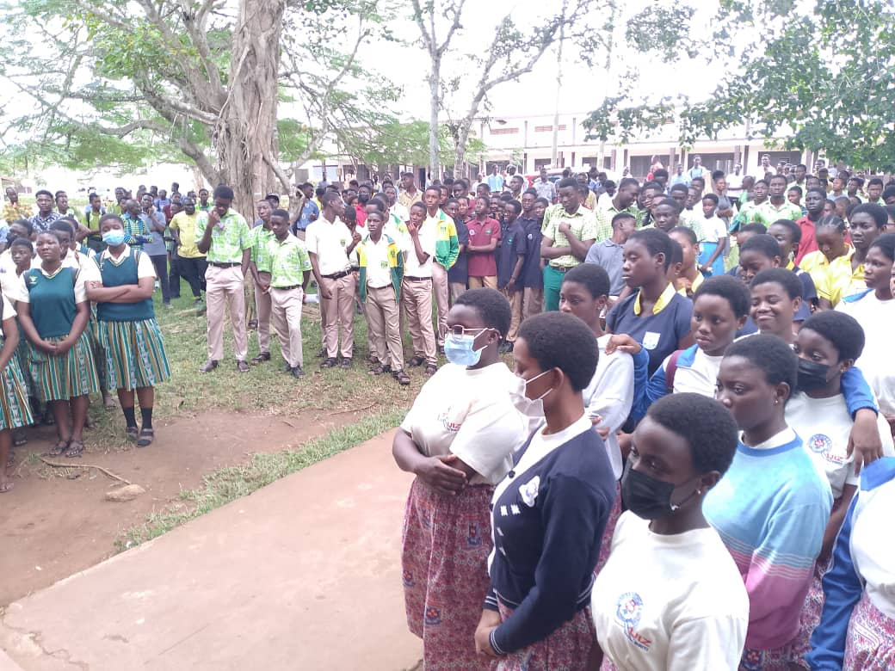

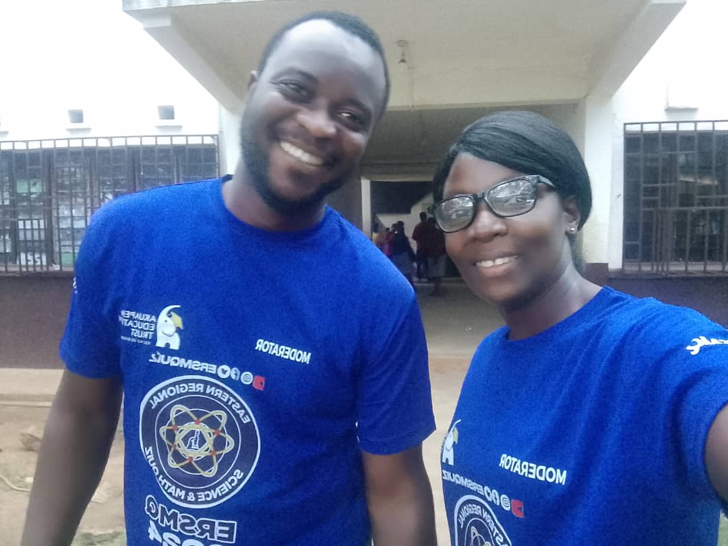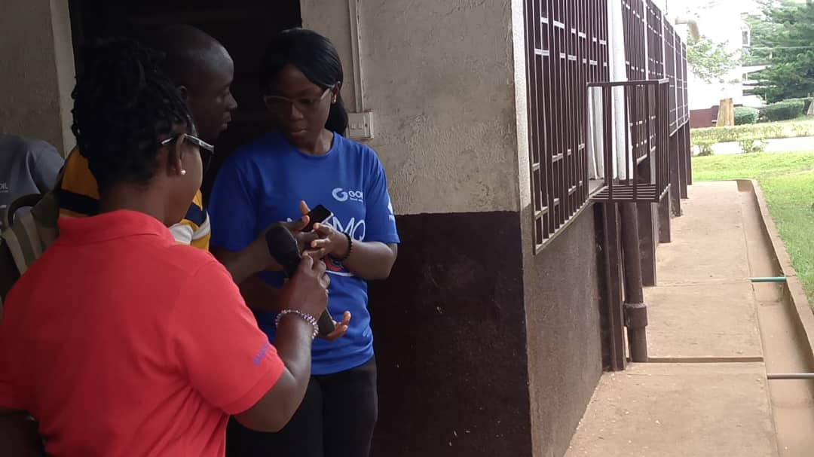

**SPONSORSHIPS /FUNDRAISING**

To apply for grant required lots of details as share below; to which I do not have assess to, and Ewoenam was on leave and just when she resumed, I was also on the run with busy schedules. Pardon the break in communication and slow implementations. However, physcal cash funds raised towards AET was GHC 3000 with breakdown indicated on the excel sheet.



**AET GRADUATING SCHOLARS’ CELEBRATION**

The celebration was planned to have taken place in march as seen in the flyer below, but due to unforeseen circumstances it was rescheduled to a new that that was to be communicated later.



Programm committee was then dissolved for the initial celebration date planning, and a new team set up during one of our talkshops .Below is the minutes taken by our scholar secretary

* **MEETING 1 - OPENING**

Our this month meeting of AET with Aunty Rachel was scheduled at 3:10pm on 25th October,2024 on our WhatApp platform dubbed AET CELEBRATION

**MEMBERS PRESENT**

* Oboubi Solomon

* Gyampo Adelaide Oppong

* Eric Kojo

* Beatrice Adu

* Priscilla Opare

* Daniel Ofori

* Takyi Deborah Safowaa

**AGENDA OF THE MEETING**

* Making the AET Website more active

* Graduation ceremony

* Meeting our board executives

**Discussion**

**Making the AET Website more active**

Members suggested that vocational, mentorship and educational programs could be organized and uploaded on the website to create awareness about AET programs to the general public.

**Graduation ceremony**

Graduation for AET schoolers was scheduled to take place on 23rd November, 2024 at the director's residence in Akropong. It was agreed that the graduands should report at Akropong on the 21th of November 2024 prior to the graduation. Accommodation will be provided for the graduands. Each graduand is permitted to invite a maximum of five guests which was later reduced to two guests.

A committee was established to oversee the planning and prepare towards the graduation ceremony. Committee members include;

* Gyampo Adelaide Oppong

* Oboubi Solomon

* Beatrice Adu

*Takyi Deborah Safowaa

**Live a good life campaign**

This year live a good life campaign was scheduled to take place on the 22nd of November,2024. The topic and the school to visit will be discussed at the appropriate time.

**Meeting with the Board executives**

A meeting between the graduands and the Board executives will take place on the 23rd of November,2024.

**Other matters**

* The members in attendance suggested that AET should revive their article writing, story reading and mentorship programs.

**NOTES**

* All scholars are to submit their story, TRULY I HAVE MADE IT, an article, and a personal picture (formal) latest by 10th November, 2024.

* Attire for the living a good life campaign is T shirt on Jeans.

* T shirt will be provided by AET therefore, each member should submit their preferred size and colour to Adelaide Oppong Gyampo as early as possible.

**Adjournment**

The meeting was adjourned at 4:00pm. Enhance Aunty Rachel declared the adjournment with a closing speech and a prayer.

**Submitted by** Gyampo Adelaide Oppong

**Approved by** Aunty Rachel

* **MEETING 2- OPENING**

A meeting between the graduation planning committee and Aunty Rachel between 6:05pm to 6: 45pm on the 26th October,2024 on our Whatapp platform dubbed AET Planning Committee.

**MEMBERS PRESENT**

Gyampo Adelaide Oppong

Oboubi Solomon

Adu Beatrice

Opare Priscilla

Takyi Deborah Safowaa

**AGENDA OF THE MEETING**

* Program Outline

* Selection of Schools for the Living a Good Life Campaign

* T Shirt for the program

Discussion

Program outline

* It was proposed that the Scholars report to Akropong on the 19th of November, 2024.
* Mentorship and Rehearsal sessions will be held on the 20th of November,2024 at the AET Office premises - Akropong for the scholars in preparation towards the living a good life campaign which will take place on 21st November,2024 to 22nd November,2024.
* The graduation ceremony is scheduled to start at 10am on Saturday 23rd November, 2024. There will be a movie night with popcorn on that evening.
* The committee appointed Beatrice Adu and Priscilla Opare to over see the movie night with popcorn.

Selection Schools for the Living a Good Life Campaign

Three schools were selected for the living a good life campaign. These schools are Adukrom Presby JHS, Adukrom Methodist and Dawu. The team for the campaign is "YES I CAN”. So verniers such as Exercise books and pens will be distributed among the teachers and students in each school. The committee appointed Oboubi Solomon and Takyi Deborah Safowaa to visit the schools and seek permission for campaign to be carried out.

T-shirts for program

Scholars’ names will be printed on the T Shirt for easy identification. All scholars are to submit their names, sizes and preferred colours to Gyampo Adelaide Oppong for early facilitation.

Other Matters

* It was suggested that soverniers could be distributed in the course of the graduation ceremony.

Adjournment

The meeting was adjourned at 6:45pm. Priscilla Opare declared the adjournment of the meeting and a prayer was said by Takyi Deborah Safowaa.

Submitted by Gyampo Adelaide Oppong

Approved by Aunty Rachel

**AET CHRISTMAS ROLL**

As part of our social responsibility, it is my quest to appeal that we reach out to children on the Akuapem ridge to put a smile on their faces with a Christmas package. This package should be for Children below 12years.As part of the celebration, the kids could exhibit their skills, talents and creativity. This is to bring them together as another means of outreach and AET visibility.so as to enhance impact in the Akuapem municipality.

**BOARD MEETING**

This year began with the wish to meeting the board quarterly as planned in the years forecast, as a matter of fact, till date I have not been introduced to any board member. I have booked to meet the board chair severally but to no avail due to number of church personnel bookings.

**NOTE**

* There should be a press release and an opening for application from 5th December to 20th January 2025, where all documents are uploaded for perusal.
* Pending graduation celebration to come off 20th to 24th of November 2024 with details;

20th November- arrivals.

21st November-Career guidance and talks.

22nd November- School outreach.

23rd November-Graduation celebration and Movie Night.

24th November-Thanksgiving at Christ Church/Grace Church and departure.

For any clarifications, detailed discussion would be given during the awaiting scheduled meeting.